The Python Match Statement

Instead of writing many if-else statements, you can use the match statement.
The match statement selects one of many code blocks to be executed.

match expression:
case x:
code block
case y:
code block
case z:
code block

case _:

default case

Example:

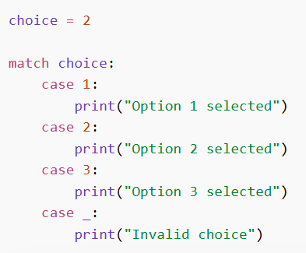

Use the pipe character | as an or operator in the case evaluation :

Example:

day = 4
match day:
case 1 | 2 | 3 | 4 | 5:
print("Today is a weekday")
case 6 | 7:
print("weekends!")

Case _if: (match anything, but only if this condition is true)

Syntax: case _ if condition:

Example:

num = 10
match num:
case _ if num > 0:
print("Positive number")
case _:
print("Other")

Using Strings in case

You can match string values directly in match-case.

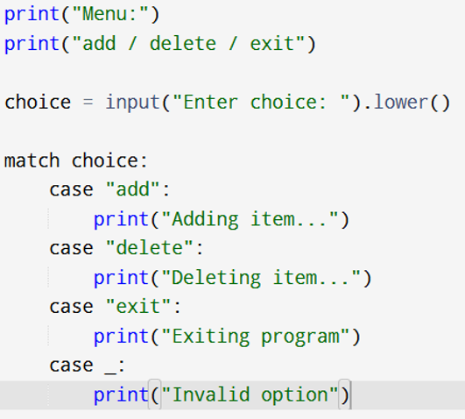

PART -A
1. Write a Python program that accepts a number as input and uses the match-case statement to classify the number.
The program should display:
- “Odd group” for values 1, 3, or 5
- “Even group” for values 2, 4, or 6
- “Invalid” for any other value

2.Write a Python program that accepts a single character as input and determines its type using the match-case statement.
The program should identify whether the given character is a vowel, consonant, digit, or special character, and display the appropriate message.

PART -B

1.Examination Result Processing System
A school processes student results based on marks and attendance.
- If marks are 80 and above and attendance is 90% or above, grade is A.
- If marks are 65 to 79 and attendance is 80% or above, grade is B.
- If marks are 50 to 64, grade is C.
- If marks are below 50 but attendance is above 75%, student must Retake Test.
- Otherwise, student Fails.

Sample input

Menu
- Process result
- Exit
Enter marks: 47
Enter attendance percentage: 82

Sample output
Student must Retake Test.
2. Write a Python program using match-case to evaluate a student’s performance based on the subject and score entered by the user.

Requirements:
- Prompt the user to enter:
  - A subject name
  - A score (integer)
- Use match-case with appropriate conditions (guards) to determine the result:
  - If the subject is Physics or Chemistry and the score is 80 or above, display:
"Excellent in Science!"
  - If the subject is English or Grammar and the score is 80 or above, display:
"Excellent in English!"
  - If the subject is Maths and the score is 80 or above, display:
"Excellent in Maths!"
- For all other cases, display:
"Needs improvement in [subject]!"

PART C - Test yourself!!!
Advanced-level if-elif- else questions

Hotel Room Booking System
Write a program that asks for:
- room type (standard/deluxe/suite)
- number of nights
- peak season (yes/no)
- membership (yes/no)
Rules:
- Room rates:
  - standard = RM120 per night
  - deluxe = RM200 per night
  - suite = RM350 per night
- If peak season is yes, increase total by 20%
- If nights are more than 3, give 10% discount
- If member is yes, give additional 5% discount
- Display total payment

E-commerce Checkout Decision
Write a program that asks for:
- total purchase amount
- payment method (card/ewallet/cash)
- coupon available (yes/no)
- first-time buyer (yes/no)
Rules:
- If purchase is RM500 or more → 20% discount
- If purchase is RM200 to RM499 → 10% discount
- If coupon is yes → extra 5% discount
- If first-time buyer is yes → extra 5% discount
- If payment method is ewallet → cashback RM15
- Display final amount and cashback if any

Smart Traffic Fine System
Write a program that asks for:
- speed limit
- vehicle speed
- whether the driver has a valid license (yes/no)
- whether the driver ran a red light (yes/no)
Rules:
- If the driver has no valid license → add RM300 fine
- If speed exceeds limit by:
  - 1 to 20 km/h → RM100
  - 21 to 40 km/h → RM200
  - above 40 km/h → RM500
- If red light violation is yes → add RM250
- If total fine exceeds RM600 → display License Review Required

